Request Room Cleaning
USE CASE DIAGRAM

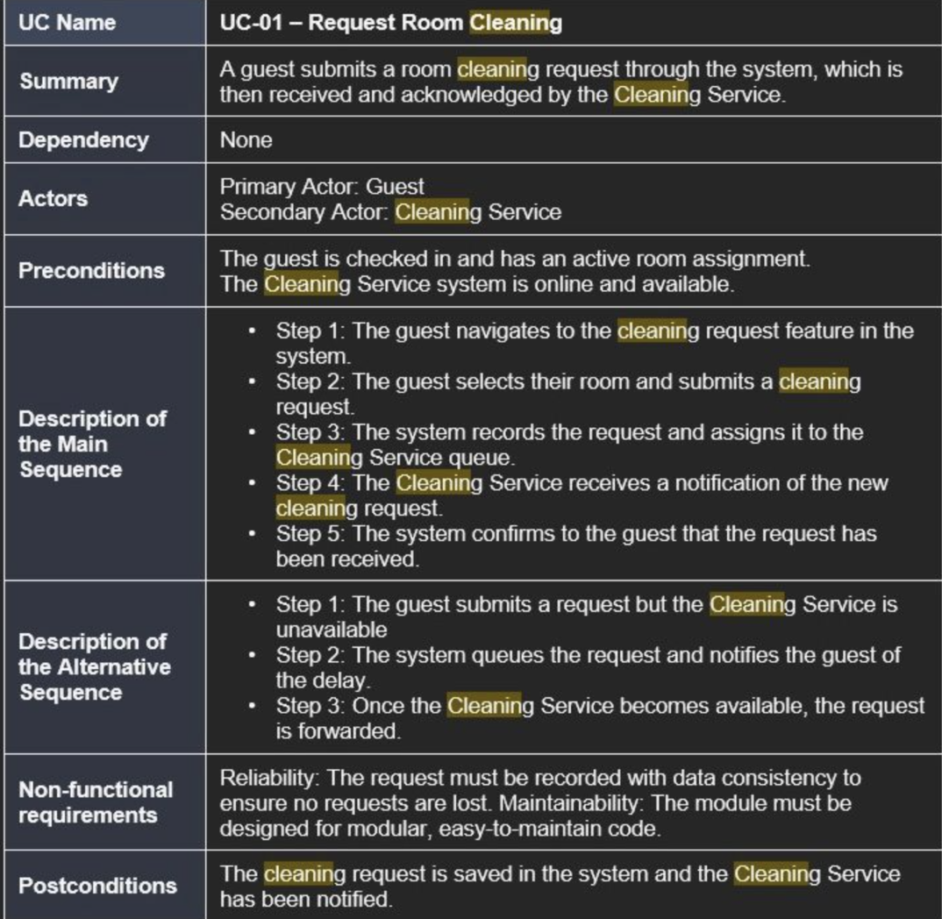

ACTIVITY DIAGRAM

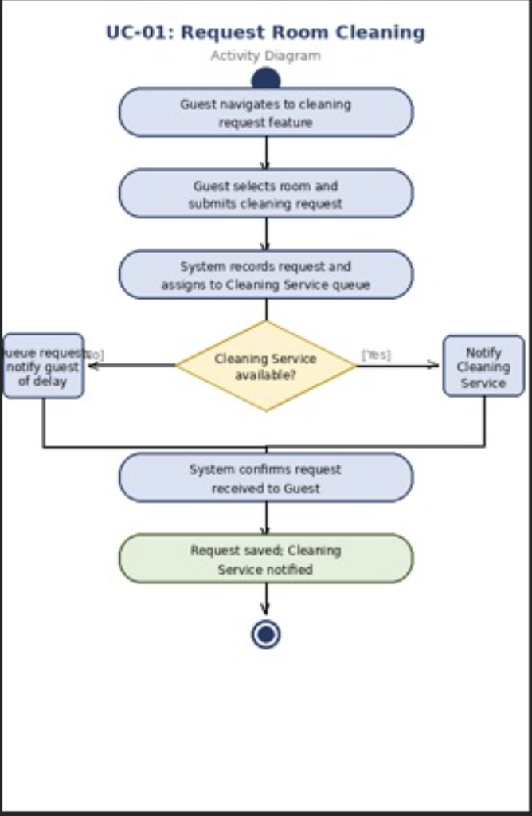

SEQUENCE DIAGRAM-REQUEST ROOM CLEANING

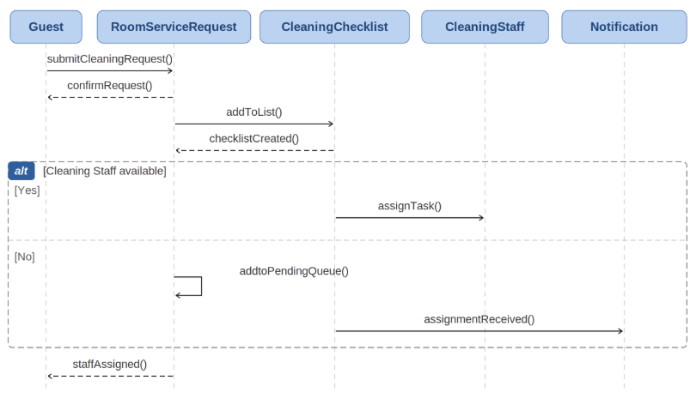

COLLABORATION DIAGRAM

